ROYALTY, ART & SPIRITUALITY-JOURNEY THROUGH HEART OF INDIA
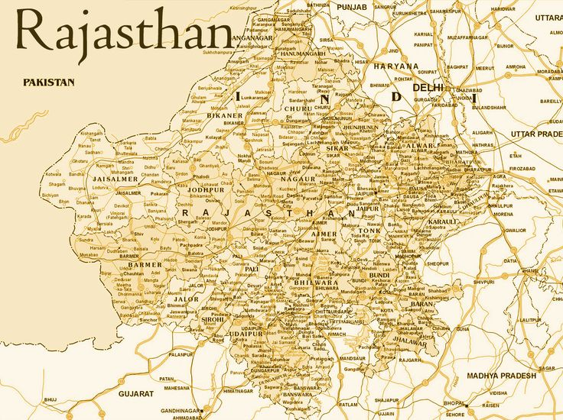

ITINERARY PUBLISHED:
15 MAR’27 | DAY 01 | ARRIVE DELHI
Meeting and assistance upon arrival at Delhi International Airport transfer to hotel in Delhi. Upon arrival check in at hotel in Delhi.

Delhi – Where Centuries of History Meet the Pulse of Modern India: Few capital cities in the world possess a history as rich, captivating, and enduring as Delhi, the timeless capital of India. For over a millennium, this legendary city has stood at the crossroads of empires, drawing successive dynasties—including the Mongols, Turks, Persians, Afghans, Mughals, and the British—each leaving behind an extraordinary architectural, cultural, and historical legacy that continues to define the city's unique character.

Dinner & overnight stay at hotel in Delhi
16 MAR’27 | DAY 02 | DELHI
Morning after breakfast proceed for Delhi Sightseeing – A Journey Through the Capital’s Heritage
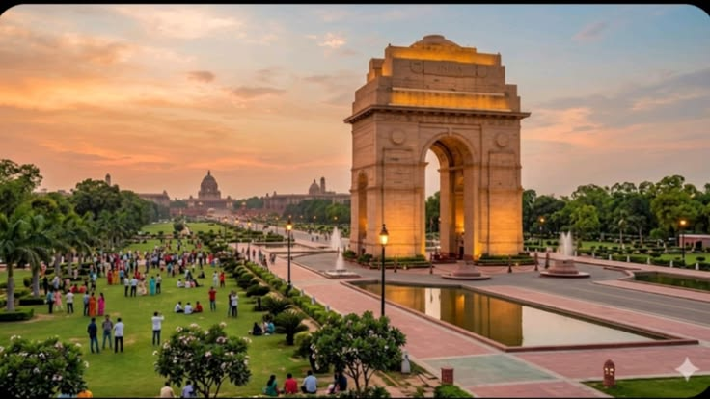
Explore the contrasting character of New Delhi and Old Delhi, where grand colonial architecture, magnificent monuments, vibrant bazaars, and centuries of history come together to reveal the many facets of India’s capital. Begin your exploration of New Delhi, distinguished by its elegant British colonial architecture, broad tree-lined avenues, landscaped boulevards, and stately government buildings. Visit the Laxminarayan Temple (Birla Mandir), a beautifully designed modern Hindu temple known for its graceful architecture and spiritual ambience. Continue to India Gate, the imposing 42-metre-high war memorial arch that stands as one of the most recognisable landmarks of the capital. Drive past the magnificent Parliament House and the Secretariat buildings, followed by the impressive Rashtrapati Bhavan, the official residence of the President of India. Together, these monumental structures reflect the architectural grandeur and historic evolution of New Delhi. Continue to Qutub Minar, one of Delhi’s most celebrated monuments and a UNESCO World Heritage Site. Rising majestically against the Delhi skyline, this remarkable medieval tower is adorned with intricate carvings and inscriptions, standing as a magnificent testament to the architectural and cultural heritage of the period.

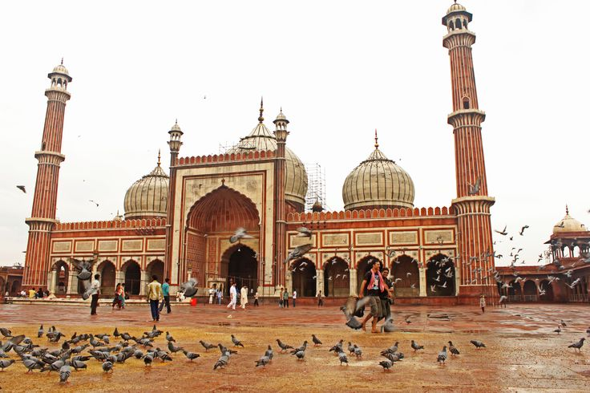
The experience then takes you into the vibrant heart of Old Delhi, beginning with a visit to the historic Jama Masjid, commissioned in the 17th century by Mughal Emperor Shah Jahan. Its impressive courtyards, soaring minarets, and red sandstone and marble architecture make it one of the finest examples of Mughal religious architecture in the city. Continue to Chandni Chowk, the historic commercial heart of Old Delhi, where narrow lanes, colourful markets, traditional shops, street-food stalls, and the lively rhythm of everyday life create an unmistakably authentic Delhi experience. A drive past the magnificent Red Fort, with a brief photo stop, offers a glimpse of another great symbol of the Mughal era. Conclude the sightseeing at Raj Ghat, the serene memorial marking the cremation site of Mahatma Gandhi. Set amidst peaceful landscaped gardens, it provides a quiet and reflective conclusion to a day spent discovering Delhi’s remarkable history and heritage

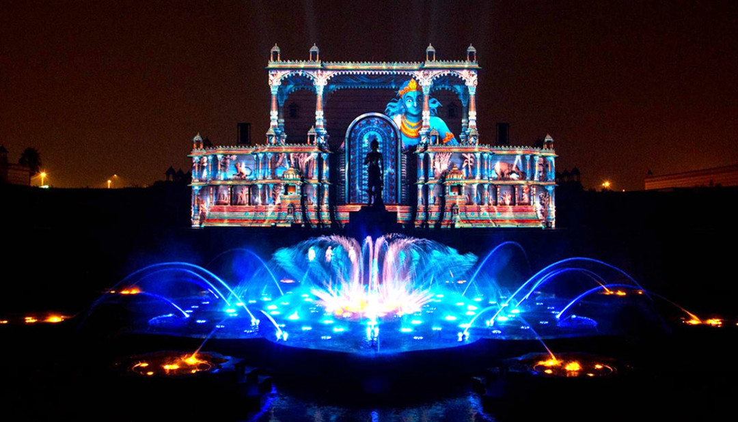
Afternoon proceed for an astonishing and beautiful fountain show at Akshardha Temple
As twilight descends, visitors are invited to take their seats within the magnificent step-well amphitheatre of Swaminarayan Akshardham Temple and immerse themselves in an experience that transcends time and reality. The Sahaj Anand Water Show unfolds as a profound journey into eternal truths, where storytelling, spirituality, and cutting-edge technology converge in perfect harmony. Set within the grand Yagnapurush Kund—a stunning replica of traditional Indian step-wells spanning. At its focal point lies a sacred nine-lotus design, inspired by ritual yantras used in Hindu ceremonies, symbolizing cosmic harmony. Presiding over this majestic space is the 27-foot-tall bronze murti of Neelkanth Varni, whose serene presence evokes inspiration, devotion, and inner strength. The 24-minute presentation is a breathtaking orchestration of multi-sensory elements, seamlessly blending multi-colour lasers, high-definition projections, dynamic water jets, underwater flames, surround sound, and live performances. Together, they bring to life a timeless narrative drawn from the ancient Kena Upanishad, one of the most revered texts of Vedic wisdom. The story unfolds with the playful innocence of children by a tranquil lake, whose joy and creativity give rise to a delicate flower formed from water. However, their lighthearted celebration inadvertently disturbs the devas—the powerful gods of the elements—who are reveling in their triumph over evil. What follows is a compelling interplay between humility and pride, innocence and power, as the fragile beauty of the children’s creation stands threatened by divine wrath. This extraordinary presentation, crafted through the collaboration of international experts alongside dedicated BAPS volunteers and sadhus, is far more than a visual spectacle. It is a deeply moving spiritual experience that resonates with audiences of all ages, leaving them inspired, introspective, and enriched.

Dinner & overnight stay at hotel in Delhi

17 MAR’27 | DAY 03: | DELHI – JAISALMER (6E 6677 – 13:30Hrs / 15:15Hrs)
Morning on time transfer to Delhi airport to board flight for Jaisalmer. Meeting and assistance upon arrival at Jaisalmer airport and transfer to hotel. Upon arrival check in at the hotel.

Jaisalmer – The Golden City of the Thar: The captivating city of Jaisalmer, founded in 1156 AD by Prince Jaisal, rises like a golden jewel from the vast expanse of the Thar Desert. Often celebrated as the “Golden City,” Jaisalmer derives its distinctive character from the warm honey-gold hue of its yellow sandstone architecture, which glows magnificently as the setting sun bathes its ancient walls in a luminous golden light. Encircled by crenellated fortifications and threaded with narrow, atmospheric lanes, the old city possesses an extraordinary medieval charm. Exquisitely carved façades, ornate balconies, finely detailed windows and magnificent sandstone buildings reveal the exceptional craftsmanship that has shaped Jaisalmer through the centuries.

Dinner & overnight stay at hotel in Jaisalmer

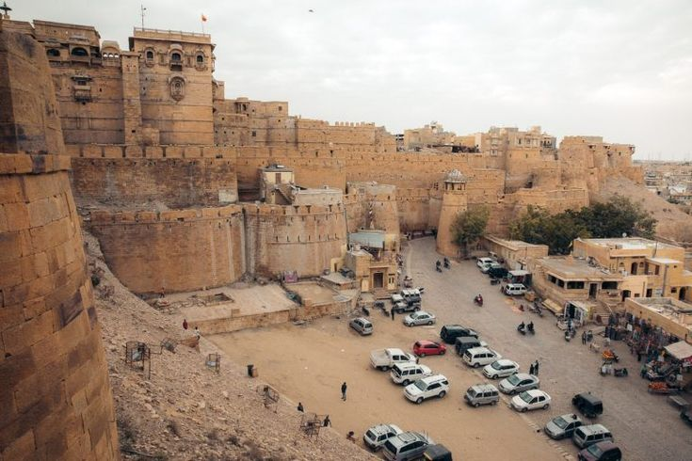
18 MAR’27 | DAY 04: | JAISALMER
Morning after breakfast proceed for Jaisalmer Sightseeing – A Golden Journey Through the Thar: Throbbing in the heart of the Thar Desert, Jaisalmer is an intricately crafted wonderland of golden sandstone, timeless heritage and enchanting desert charm. Embark on a half-day sightseeing tour through this captivating “Golden City,” where centuries-old architecture and living traditions unfold around every corner. Begin with the magnificent Jaisalmer Fort, built by Rawal Jaisal and dramatically poised atop the approximately 80-metre-high Trikuta Hill. Remarkably, the fort continues to be a living citadel, with a significant part of the city’s population still residing within its ancient walls. Wander through its atmospheric lanes and discover the beautifully carved Jain temples, dating from the 12th to the 15th centuries, renowned for their exquisite sculptures and intricate architectural detailing. Continue to Badal Vilas Palace, the former residence of the ruling family and a fine example of Jaisalmer’s later royal architecture. The sightseeing experience then unfolds through the city’s celebrated merchant havelis, magnificent residences that reflect the wealth and artistic sophistication of Jaisalmer’s prosperous trading families. Admire Patwon Ki Haveli, an impressive five-storey mansion dating to 1805, distinguished by its elaborately carved pillars, ornate façades and beautiful murals. Continue to Salim Singh Ki Haveli, known for its distinctive architectural character, and Nathmalji Ki Haveli, celebrated for its intricate craftsmanship and richly ornamented sandstone façade.

Afternoon have the experience reaches its most atmospheric moment towards sunset, when a camel ride across the dunes offers an unforgettable encounter with the Thar. As the sun slowly sinks beyond the horizon and casts a warm golden glow across the endless sands, the tranquil rhythm of the camel safari evokes the timeless romance and.

Dinner & overnight stay at hotel in Jaisalmer

19 MAR’27 | DAY 05: | JAISALMER – POKHARAN – JODHPUR (272Kms, 04Hrs drive)
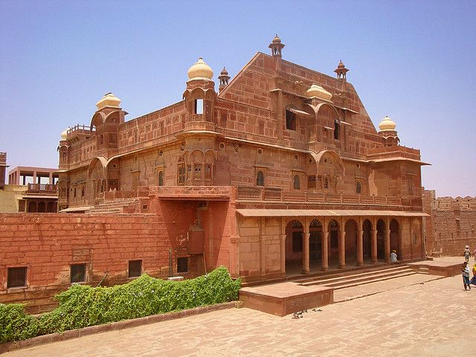
Morning after breakfast drive to Jodhpur enroot visiting Pokhran Fort, also known as Balagarh Fort, a distinguished Rajput stronghold rising amidst the stark and captivating landscapes of the Thar Desert. Built in the 14th century by Rao Maldeo, the fort is an impressive example of traditional Rajput architecture, characterised by its imposing sandstone walls, fortified gateways and finely carved architectural details. Constructed as both a fortress and royal residence, Pokhran Fort reflects the remarkable ability of Rajput architects to combine military strength with the elegance and comforts of royal living. Its architecture was thoughtfully adapted to the demanding desert environment, with carefully planned courtyards, shaded spaces and thick sandstone walls providing protection from the harsh climate.
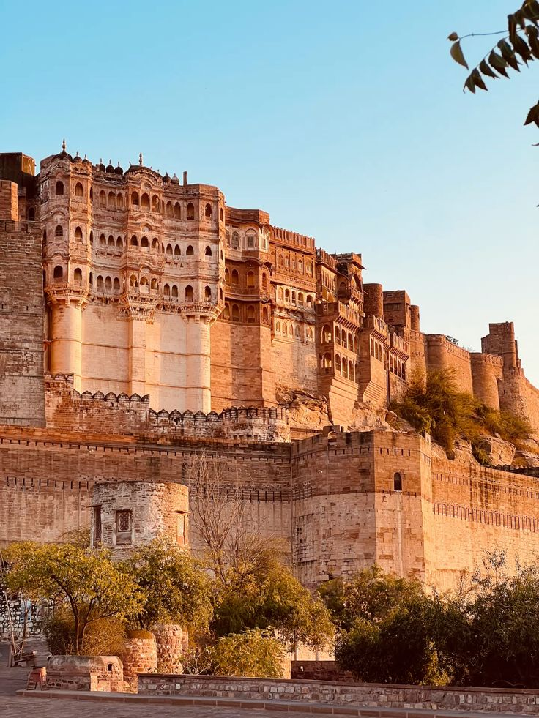
Continue drive to Jodhpur. Upon arrival check in at hotel in Jodhpur. Afternoon proceed for Jodhpur City Tour – Forts, Royal Treasures & Architectural Elegance: Begin your half-day sightseeing tour with a visit to the magnificent Mehrangarh Fort, dramatically positioned atop a low sandstone hill overlooking the Blue City. One of Rajasthan's most impressive fortresses, its imposing ramparts enclose a remarkable collection of royal palaces, courtyards and richly decorated chambers. Explore the exquisite palace apartments, including the Sukh Mahal, Phool Mahal and Sheesh Mahal, each offering a fascinating glimpse into the refined lifestyle of the erstwhile Marwar royalty. Their ornate interiors are complemented by an exceptional collection of jewellery, royal costumes, armour, palanquins, howdahs and other historic artefacts, preserving the splendour and traditions of the Rathore dynasty. Continue to the elegant Jaswant Thada, a beautifully crafted white-marble memorial built in 1899 in honour of Maharaja Jaswant Singh II. Set amidst tranquil surroundings, the memorial is adorned with delicate marble latticework and fine architectural details. It subsequently became the royal cremation ground, with several additional cenotaphs constructed here in memory of members of the royal family. Later, visit the museum at Umaid Bhawan Palace, one of India's grandest palace residences and an architectural landmark of 20th-century Jodhpur. The museum presents an engaging collection of royal memorabilia, vintage photographs, clocks, furniture, decorative arts and other artefacts, offering an insight into the lifestyle and legacy of the Jodhpur royal family.

Dinner & overnight stay at hotel in Jodhpur

20 MAR’27 | DAY 06: | JODHPUR – RANAKPUR – UDAIPUR (262Kms, 05Hrs drive)
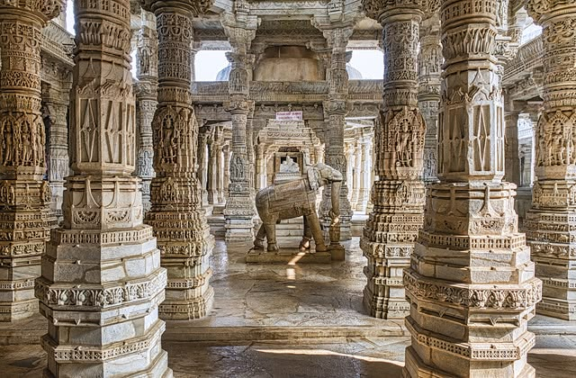
Morning after breakfast drive to Jodhpur enroot visiting Ranakpur – A Marble Masterpiece of Jain Architecture: Nestled amidst the tranquil Aravalli Hills, approximately 90 km from Udaipur, Ranakpur is home to one of India’s most magnificent Jain temple complexes and one of the finest expressions of medieval western Indian temple architecture. Dating from the 15th century, the complex is centred around the spectacular Chaumukha Temple, dedicated to Adinath, the first Tirthankara of Jainism. Built almost entirely in beautifully worked marble, the temple is a masterpiece of intricate craftsmanship. Its walls, pillars and domes are adorned with exquisite carvings depicting mythological figures, floral patterns, geometric motifs and finely detailed ornamental designs. The temple is particularly renowned for its 1,444 intricately carved marble pillars, each uniquely designed, creating an extraordinary interplay of light, shadow and symmetry throughout the vast interior.

Continue drive to Udaipur. Upon arrival check in at hotel in Udaipur.
Udaipur – The Romantic Soul of Rajasthan: Nestled amidst the undulating Aravalli Hills of southern Rajasthan, Udaipur is one of India's most enchanting cities and is widely regarded as one of the country's most romantic destinations. With its shimmering lakes, magnificent marble palaces, beautifully landscaped gardens and lush green hills, the city presents a picture of timeless elegance and has earned the evocative title of “Venice of the East.” Founded by Maharana Udai Singh II in 1568, Udaipur was conceived as a traditionally planned and fortified city, with imposing palaces, ornate temples, elegant havelis and defensive structures woven into its landscape. The city's architecture reflects the grandeur and sophistication of the Mewar dynasty, while its lakes and surrounding hills lend it an unmistakable sense of tranquillity.

Dinner & overnight stay at hotel in Udaipur

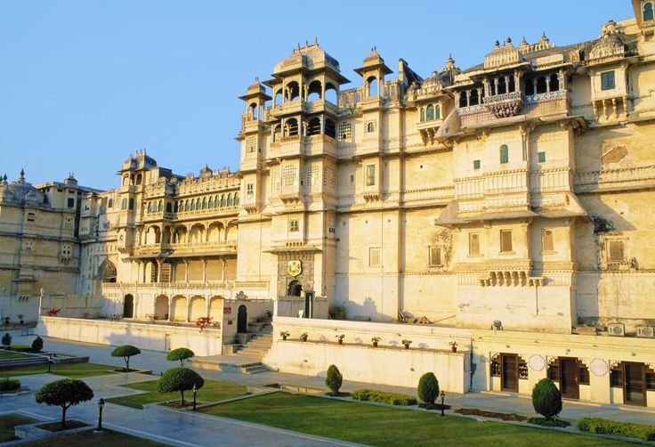
21 MAR’27 | DAY 07: | UDAIPUR
Morning after breakfast proceed for sightseeing tour of Udaipur City Tour – Palaces, Temples & Artistic Heritage: Begin your half-day sightseeing tour of Udaipur with a visit to the magnificent City Palace and Museum, an extraordinary complex rising majestically above the shores of Lake Pichola. Considered one of the largest palace complexes in India, it represents a harmonious fusion of Rajput architectural traditions and Mughal influences. Explore its ornate courtyards, grand halls, balconies and richly decorated chambers, while the museum offers fascinating insights into the splendour and lifestyle of the former Mewar rulers.
Continue to the beautiful Jagdish Temple, an impressive 17th-century Hindu temple dedicated to Lord Vishnu. Its towering structure and intricate stone carvings make it one of Udaipur's most significant religious and architectural landmarks. Take a scenic drive around Fateh Sagar Lake, one of Udaipur's most picturesque lakes, framed by the Aravalli Hills and surrounded by a tranquil landscape. The drive offers wonderful views of the water and the city's elegant lakeside setting. Visit Saheliyon-ki-Bari, meaning the “Garden of the Maids of Honour,” a graceful ornamental garden created as a retreat for the royal ladies. Beautiful fountains, marble kiosks, lotus pools, manicured lawns and shady walkways create an atmosphere of serenity and refinement, offering a glimpse into the leisure and elegance of the Mewar court. Conclude the sightseeing with a visit to the Bharatiya Lok Kala Mandal, also known as the Folk Art Museum, where an engaging collection of traditional Rajasthani folk art, costumes, puppets, masks, musical instruments and decorative crafts celebrates the vibrant cultural traditions of the region.

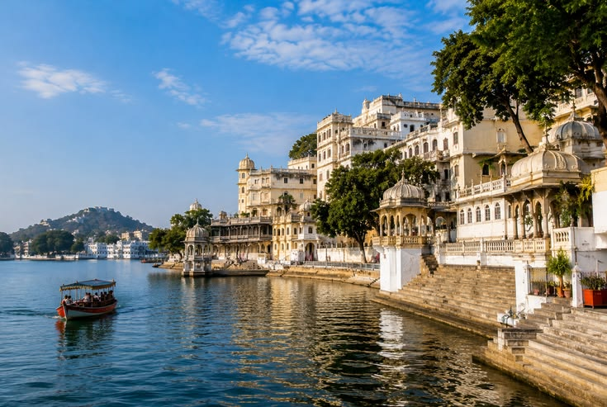
Afternoon enjoy boat ride at Lake Pichola & Jag Mandir – Udaipur’s Timeless Lakeside Beauty: Enjoy a leisurely boat ride on the enchanting Lake Pichola, one of Udaipur's most iconic and picturesque landmarks. Stretching approximately 4 km in length and 3 km in width, the lake is surrounded by the dramatic Aravalli Hills and beautifully framed by magnificent palaces, historic havelis, ancient temples, ghats and elegant embankments. As the boat glides across the tranquil waters, enjoy spectacular panoramic views of Udaipur's architectural treasures reflected against the shimmering surface of the lake. The changing light of the day lends an especially magical character to the landscape, with the palaces and surrounding hills taking on warm golden hues around sunset. Continue to Jag Mandir, a graceful island palace rising from the waters of Lake Pichola. Explore its elegant courtyards, marble structures and beautifully landscaped surroundings, including the exquisite Gul Mahal Pavilion, admired for its refined architecture and historical significance. The experience offers a wonderful opportunity to appreciate Udaipur from a different perspective, where water, architecture, nature and royal heritage come together in perfect harmony.

Dinner & overnight stay at hotel in Udaipur

22 MAR’27 | DAY 08: | UDAIPUR – CHITTORGARH – BUNDI (265Kms, 05Hrs drive)
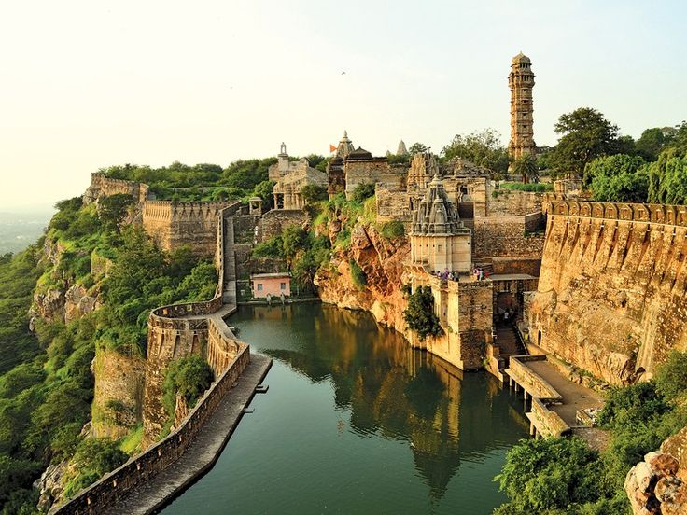
Morning after breakfast proceed for Bundi enroot visiting Chittorgarh Fort – A Monument to Rajput Valour & Glory: Visit the magnificent Chittorgarh Fort, one of Rajasthan's most imposing historic landmarks and an enduring symbol of Rajput courage, sacrifice and pride. Rising dramatically above the surrounding landscape, this vast fortified complex preserves the remnants of a once-powerful Rajput capital, where legends of valour and heroic resistance have been woven into the history of Mewar. According to tradition, the origins of the fort are associated with Bhim, one of the Pandavas of the Mahabharata. Although the ancient city within the fort now lies largely deserted, its impressive palaces, temples, towers and gateways continue to evoke the grandeur of its illustrious past. Explore the remains of Rana Kumbha's Palace, once one of the most important royal residences within the fort, and visit Fateh Prakash Palace, which reflects the later architectural heritage of Mewar. One of the most spectacular landmarks is the 37-metre-high Jaya Stambh, or Tower of Victory, commissioned by Rana Kumbha to commemorate his victory over the forces of the Sultan of Malwa in the 15th century. Rising majestically above the fort, the tower is richly decorated with intricate carvings depicting Hindu deities, warriors and scenes from mythology. Also admire the 22-metre-high Kirti Stambh, or Tower of Fame, an elegant Jain monument dedicated to Adinath, the first Jain Tirthankara. Its seven-storeyed structure is richly ornamented with sculptures representing Jain Tirthankaras and other sacred figures, reflecting the religious diversity and artistic sophistication of medieval Mewar. Beyond its architectural splendour, Chittorgarh carries a powerful sense of history. Its massive ramparts, ruined palaces and soaring victory towers stand as enduring reminders of a kingdom that repeatedly defended its independence against formidable adversaries.

Continue drive to Bundi. Upon arrival check in at hotel in Bundi.
Bundi – A Timeless Legacy of Rajput Grandeur: Once the capital of a powerful Rajput princely state, Bundi remains one of Rajasthan’s most enchanting and atmospheric towns, where the character of a bygone era has been remarkably preserved. Nestled within a narrow valley and surrounded by the rugged Aravalli landscape, the town retains an unmistakable medieval charm, with its winding lanes, historic architecture and tranquil ambience.

Lunch, Dinner & overnight stay at hotel in Ranthambore.

23 MAR’27 | DAY 09: | BUNDI – JAIPUR (214Kms, 03Hrs drive)
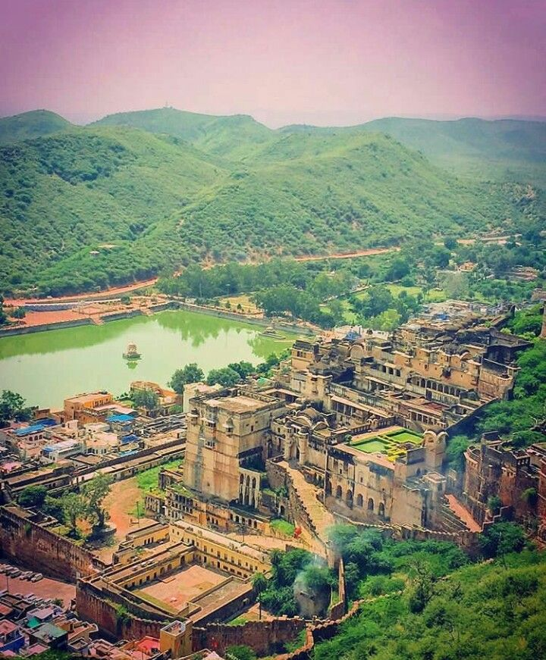
Morning after breakfast proceed for sightseeing tour of Bundi visiting Taragarh Fort & Bundi Palace – Echoes of a Royal Past: Dominating the picturesque town of Bundi from its rugged hillside, Taragarh Fort, built in 1342, stands as an imposing reminder of the region’s medieval Rajput heritage. Rising dramatically above the town and its tranquil lakes, the fort presents a striking and somewhat austere silhouette against the surrounding landscape. Within its formidable walls are enormous water reservoirs carved directly into the living rock, an impressive testament to the ingenuity of its builders, along with a historic cannon that adds to the fort’s martial character. Below the fort lies the magnificent Bundi Palace, an architectural treasure filled with intriguing remnants of its royal past. Explore its atmospheric courtyards, ornate chambers and fascinating defensive features, including concealed spy-holes, secret trapdoors and underground passages that once formed part of the palace’s intricate security and communication system. A particular highlight is the Chitrashala, celebrated for its exquisite Bundi murals. Richly detailed paintings depict episodes from the life of Lord Krishna, together with courtly scenes, religious themes and glimpses of royal life. The vibrant compositions and delicate craftsmanship provide an exceptional insight into the distinctive artistic tradition that flourished under the Bundi rulers. The palace complex also reveals an ingenious traditional water-management system, incorporating stepwells, tanks and carefully engineered channels designed to collect, store and distribute water. Together, these remarkable features illustrate the architectural sophistication, artistic refinement and resourcefulness of Bundi’s royal heritage.

Continue drive to Jaipur. Upon arrival check in at hotel in Jaipur. Jaipur – The Pink City of Royal Grandeur: Founded in 1727 by Maharaja Sawai Jai Singh II, Jaipur, popularly known as the “Pink City,” is a remarkable blend of royal heritage, architectural brilliance and meticulous urban planning. Conceived as one of India's earliest planned cities, Jaipur was designed according to the principles of the ancient Shilpa Shastra, with the city divided into nine rectangular sectors, symbolically representing the nine divisions of the universe. The city's master plan was shaped by the vision of its architects, who combined traditional Hindu principles of architecture with the refined influences of Mughal and Jain design, creating a distinctive architectural identity that continues to define Jaipur today. Broad avenues, orderly streets, grand gateways and beautifully ornamented buildings reflect the extraordinary foresight behind its creation. In 1853, the city was famously painted in its characteristic terracotta-pink colour to welcome Prince Albert, who was visiting Jaipur as part of his tour of India. The colour was subsequently preserved as a symbol of hospitality and has become inseparable from the city's identity. Today, Jaipur remains a fascinating meeting point between the past and the present. Its magnificent palaces, imposing forts, bustling bazaars and historic streets continue to evoke the splendour of the Rajput era, while modern life moves energetically around them.

Dinner & overnight stay at hotel in Jaipur.

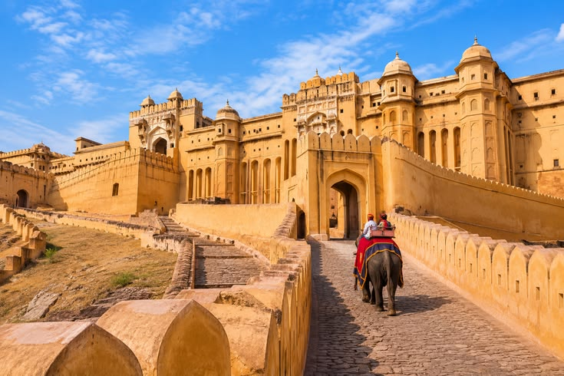
24 MAR’27 | DAY 10: | JAIPUR
Morning visit Amber Fort – A Magnificent Legacy of the Rajputs: Visit the magnificent Amber Fort, the ancient capital and stronghold of the Rajput rulers, situated approximately 11 km from Jaipur. Dramatically perched on the rugged Aravalli hills and overlooking Maota Lake, this imposing fort-palace is one of Rajasthan's finest examples of Rajput architecture, where grandeur, artistry and strategic design come together in spectacular harmony. The construction of the fort was initiated by Raja Man Singh and it remained the principal seat of the Kachwaha Rajputs until Maharaja Sawai Jai Singh II moved the capital to the newly established city of Jaipur in 1727. Explore the fort's magnificent courtyards, palaces and ceremonial spaces, including the Diwan-i-Am, or Hall of Public Audience, where the ruler received his subjects. Visit the revered Kali Temple, an important spiritual centre within the fort, before proceeding to the exquisite Jai Mandir, or Hall of Victory. The Jai Mandir is particularly renowned for its delicate inlaid panels and dazzling mirror work, which create a magical effect when illuminated. Continue to Sukh Niwas, the pleasure palace, admired for its elegant architecture and ingenious cooling system. The beautifully designed interiors and surrounding courtyards offer a glimpse into the refined lifestyle of the Rajput royalty. From the elevated terraces and ramparts of Amber Fort, enjoy breathtaking panoramic views of Maota Lake, the surrounding hills and the historic landscape below.

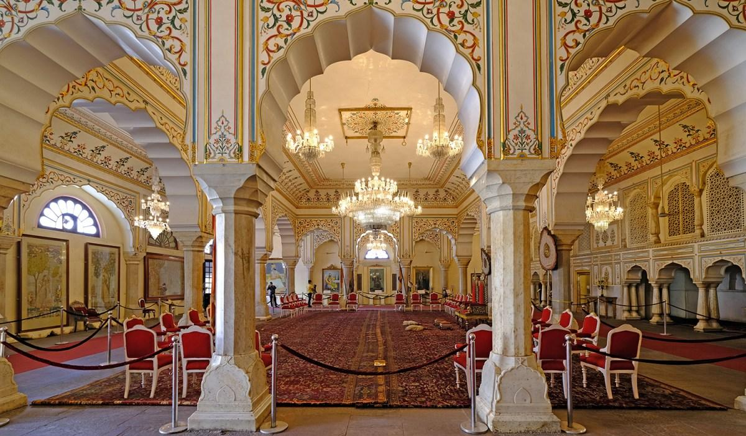
Afternoon proceed for sightseeing tour of Jaipur City Tour – Royal Heritage & Astronomical Marvels: Take a half-day tour of Jaipur, exploring its magnificent royal heritage and extraordinary architectural landmarks. Begin with a visit to the Maharaja's City Palace, an impressive complex at the heart of the walled city. Built in the 18th century, the palace occupies a significant portion of Jaipur's historic centre and continues to reflect the grandeur and refinement of the former royal court. Explore the elegant Mubarak Mahal, now home to fascinating collections of textiles, costumes and royal artefacts, as well as the museums displaying an impressive array of arms and armour. Continue through the magnificent Diwan-i-Khas and Diwan-i-Am, the private and public audience halls respectively, where the architectural details offer an evocative glimpse into the ceremonial life of the Maharajas. Continue to the remarkable Jantar Mantar, Jaipur's celebrated astronomical observatory and a UNESCO World Heritage Site. Its name is traditionally interpreted as referring to instruments used to measure celestial harmony and movements. Built by Maharaja Sawai Jai Singh II, the observatory houses a remarkable collection of monumental astronomical instruments, each designed for a specific purpose and capable of remarkably precise observations. Together, they demonstrate the extraordinary scientific knowledge and astronomical curiosity of 18th-century India. Make a photo stop at the iconic Hawa Mahal, or “Palace of the Winds,” instantly recognisable for its delicate honeycomb façade and hundreds of small windows. Built to allow royal women to observe the lively streets and processions below while remaining unseen, it has become one of Jaipur's most enduring symbols. Complete the tour with a drive through Jaipur's distinctive rose-pink residential and commercial quarters, where historic façades, bustling bazaars and everyday city life combine to create the unmistakable character of the Pink City.

Dinner & overnight stay at hotel in Jaipur
25 MAR’27 | DAY 10: | JAIPUR – RANTHAMBORE (176Kms, 03Hrs drive)
morning after breakfast drive to Ranthambore. Upon arrival check in at hotel in Ranthambore. Ranthambore – Where Wilderness Meets Royal Heritage: Discover Ranthambore National Park, one of India's most celebrated tiger reserves and a captivating destination where untamed wilderness meets a remarkable royal past. Formerly the private hunting reserve of the Maharajas of Jaipur, the area became part of Project Tiger in 1972, marking an important chapter in India's efforts to protect its magnificent Bengal tiger population. Spread across approximately 410 square kilometres, the reserve occupies a dramatic landscape where the easternmost reaches of the Aravalli Hills meet the Vindhya Range. Ancient rocky outcrops, dry deciduous forests, open grasslands and tranquil lakes create an exceptional habitat for wildlife and provide a spectacular setting for exploration. Ranthambore is particularly renowned for its Bengal tigers, and visitors staying for a couple of nights have a rewarding opportunity to encounter these magnificent animals in their natural surroundings. Alongside the tiger, the park is home to a rich variety of wildlife, including leopards, sloth bears, sambar, spotted deer, wild boar, nilgai, crocodiles and numerous species of birds.

Dinner & overnight stay at hotel in Jaipur
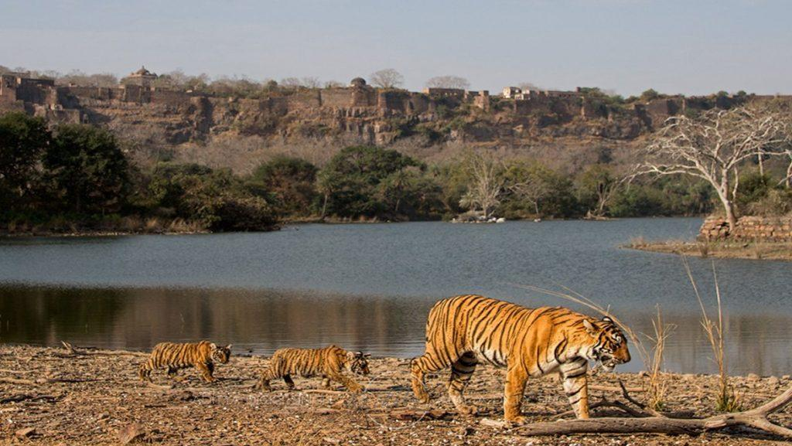
26 MAR’27 | DAY 12: | RANTHAMBORE
Enjoy morning and afternoon safari at Ranthambore national park. Ranthambore – A Rich Tapestry of Wildlife: While the Bengal tiger remains the undisputed star of Ranthambore, the reserve supports an impressive diversity of wildlife. Safari drives frequently offer opportunities to encounter large herds of chital (spotted deer) and sambar, along with sounders of wild boar, graceful nilgai antelope and the elusive chinkara gazelle moving through the open grasslands and forested terrain. The reserve is also home to sloth bears, leopards and marsh crocodiles, although sightings of these more elusive inhabitants are less predictable, adding an element of excitement to every safari. Ranthambore is equally rewarding for bird enthusiasts, with an extensive variety of resident and migratory species. Among those that may be encountered are painted and grey francolins, junglefowl, partridges, quails, crested serpent eagles, woodpeckers and flycatchers, adding colour and movement to the forest landscape. The park's lakes, ponds and seasonal waterholes attract an abundance of water birds, including storks, ducks and geese, particularly during the cooler months. Watching these birds gather around the tranquil waters, often against the backdrop of ancient ruins and rugged hills, offers a particularly memorable aspect of the Ranthambore experience.

breakfast, Lunch, Dinner and overnight stay at hotel in Ranthambore

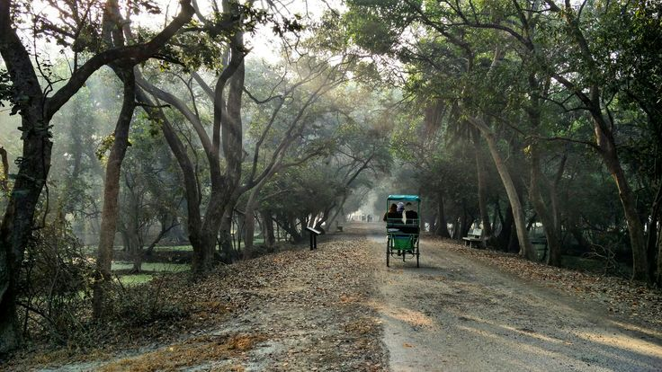
27 MAR’27 | DAY 13: | RANTHAMBORE – BHARATPUR – FATEHPUR SIKRI – AGRA (309Kms, 05Hrs drive)
Morning after breakfast drive to Agra enroot visiting Bharatpur – A Sanctuary of Avian Grandeur and Royal Heritage: Located approximately 40 kilometres south of Agra, Bharatpur is best known for the celebrated Keoladeo Ghana National Park, a UNESCO World Heritage Site and one of the world’s finest destinations for birdwatching. The park is home to an extraordinary diversity of avifauna, with more than 360 recorded species. Depending on the season, visitors may encounter elegant egrets, colourful kingfishers, graceful cranes, storks, ducks, spoonbills and various species of falcons. Historically, the sanctuary has also welcomed migratory Siberian cranes, adding to its international significance as an important wintering ground for birds along major migratory routes. Beyond its remarkable birdlife, the sanctuary supports a variety of wildlife, including deer, wild boar, hyenas, wildcats and rock pythons, making a visit an engaging experience for both bird enthusiasts and nature lovers. Exploring the tranquil waterways and verdant landscapes offers an opportunity to appreciate Rajasthan from a completely different perspective—peaceful, natural and far removed from its better-known desert landscapes and monumental forts. Bharatpur also preserves an important chapter of Rajasthan’s military and royal history in the form of Lohagarh Fort. Built in the 18th century, this formidable fortress is renowned for its exceptional strength and resilience. Within its historic precincts are royal palaces and a museum housing artefacts and exhibits that provide an insight into the region’s regal past.
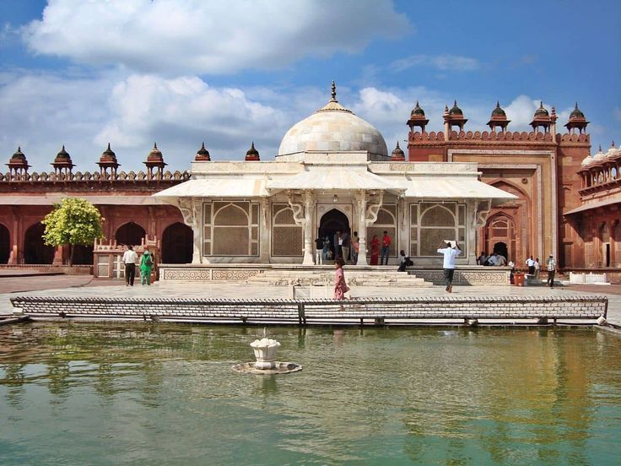
Fatehpur Sikri – The Forgotten Imperial Capital: Step into the remarkable world of Fatehpur Sikri, the magnificent fortified city conceived by the Mughal Emperor Akbar in 1569 as the seat of his imperial capital. Built in striking red sandstone, this extraordinary city flourished for only a brief period before being abandoned approximately fifteen years later, traditionally attributed to a severe scarcity of water. Today, its remarkably preserved palaces, courtyards and monuments stand as an evocative testament to the ambition and architectural vision of the Mughal Empire. Explore the majestic Jami Masjid, one of the finest examples of Mughal religious architecture, and visit the elegant white-marble tomb of the revered Sufi saint Salim Chishti, whose blessings are closely associated with the birth of Akbar’s heir. Continue through the imperial complex to discover the graceful Panch Mahal, an extraordinary five-storeyed pavilion designed with an airy succession of diminishing columns, as well as the Diwan-i-Khas, the celebrated Hall of Private Audience, and the palaces and courtyards that once formed the heart of imperial life. What makes Fatehpur Sikri particularly fascinating is its distinctive architectural synthesis. Mughal and Islamic design traditions are beautifully interwoven with Hindu and Jain decorative influences, visible in the intricate carvings, ornamental motifs, columns and architectural details throughout the complex.

Continue drive to Agra. Upon arrival check in at hotel in Agra.
Agra – The Mughal City of Eternal Grandeur: Although Agra’s history stretches back centuries, the city rose to particular prominence during the reign of the Afghan ruler Sikandar Lodi, who established it as the capital of his empire. A defining chapter in Agra’s history began in 1526, when the Mughal Emperor Babur conquered the city and began shaping its architectural and cultural character. Over the following centuries, Agra witnessed the extraordinary splendour of the Mughal Empire under three of its most celebrated rulers—Akbar, Jahangir and Shah Jahan. Their reigns transformed Agra into a magnificent centre of imperial power, artistic refinement, architecture and craftsmanship. The city flourished with grand forts, elegant palaces, exquisite gardens and monumental structures, leaving behind an architectural legacy that continues to define Agra’s identity today.

Rest of the day free for relaxation/explore local bazaars of Agra

Dinner and overnight stay at hotel in Agra

28 MAR’27 | DAY 14: | AGRA
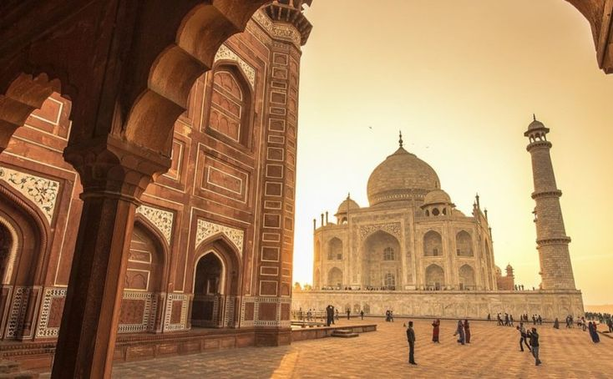
Morning after breakfast proceed for sightseeing tour of Agra visiting Taj Mahal – A Monument to Eternal Love: Emperor Shah Jahan, a passionate patron of architecture and the arts, envisioned a monument of such beauty and permanence that it would transcend generations and remain etched in the memory of the world. In memory of his beloved wife, Mumtaz Mahal, he chose an exceptionally evocative setting on the banks of the Yamuna River, where the monument could also be admired from the imperial apartments of Agra Fort, further upstream. Construction of the Taj Mahal commenced in 1631, marking the beginning of one of the most ambitious architectural undertakings of the Mughal era. It took approximately 22 years and the efforts of around 20,000 craftsmen and artisans to bring Shah Jahan’s extraordinary vision to completion. Built predominantly in luminous white marble, the Taj Mahal is a remarkable study in contrasts—monumental yet remarkably delicate, majestic yet profoundly intimate. Its grand architectural composition is complemented by an extraordinary level of precision, from its harmonious proportions and graceful domes to its intricate marble inlay, delicate ornamentation and finely executed craftsmanship. More than an architectural masterpiece, the Taj Mahal stands as an enduring expression of love, remembrance and artistic devotion. Its ethereal beauty changes subtly with the light of the day, creating an atmosphere that is at once serene, poignant and unforgettable.

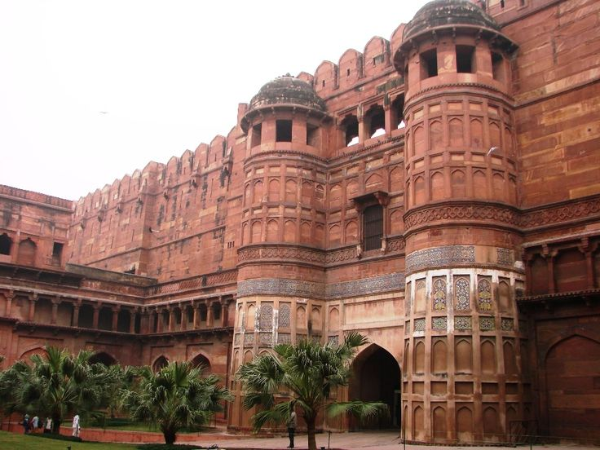
Agra Fort – The Imperial Citadel of the Mughal Empire: The imposing Agra Fort, one of India’s most remarkable fortified monuments, was commissioned by Emperor Akbar in 1565 and subsequently expanded and embellished by successive Mughal rulers. Constructed predominantly in striking red sandstone, this formidable citadel stretches for approximately 2.5 kilometres, enclosed by massive defensive walls and a broad moat that once provided an additional layer of protection. Far more than a military stronghold, Agra Fort evolved into a magnificent imperial city within a city, serving as the principal residence and seat of power of the Mughal emperors. Within its imposing walls lies an extraordinary ensemble of palaces, audience halls, mosques, towers and royal apartments, each reflecting the architectural refinement and grandeur of the Mughal court. Among its most distinguished monuments are the elegant Moti Masjid, the Diwan-i-Am, or Hall of Public Audience, where the emperor received petitions and addressed matters of state, and the richly ornamented Diwan-i-Khas, the Hall of Private Audience, reserved for imperial meetings and distinguished guests. Explore the Octagonal Tower, an exquisite vantage point associated with Shah Jahan, as well as the graceful Jahangir’s Palace, which reflects the architectural traditions of Akbar’s reign. Throughout the complex, beautifully carved stonework, delicate ornamentation and expansive courtyards reveal the remarkable craftsmanship that characterised Mughal architecture.
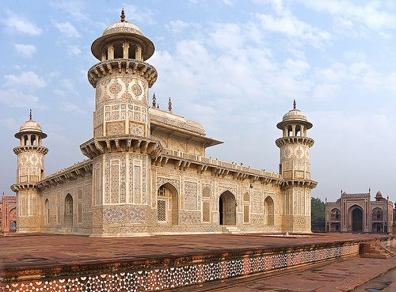
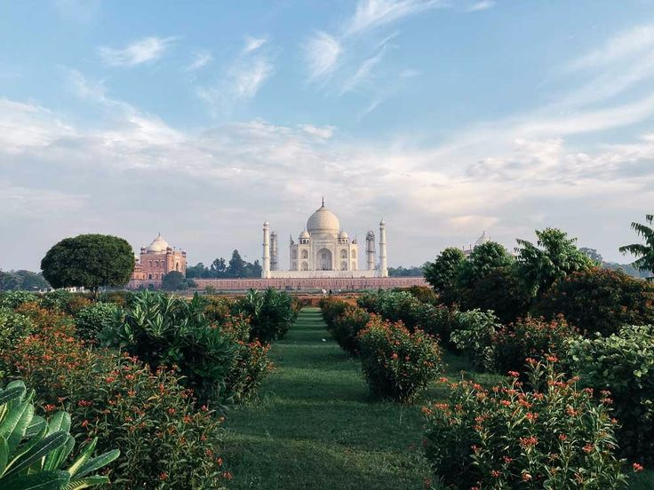
Itmad-ud-Daulah – The Jewel Box of Agra: Nestled gracefully on the banks of the Yamuna River, the exquisite Tomb of Itmad-ud-Daulah was commissioned in 1622 as the mausoleum of Mirza Ghiyas Beg, the father of Empress Nur Jahan, wife of the Mughal Emperor Jahangir. Though modest in scale compared with Agra’s monumental masterpieces, the tomb possesses an extraordinary delicacy and refinement that make it one of the city’s most enchanting monuments. Often affectionately referred to as the “Baby Taj,” Itmad-ud-Daulah is celebrated for its luminous white-marble façade, intricate pietra-dura-style stone inlay, delicate lattice screens and finely detailed ornamental work. It is particularly significant in Mughal architectural history as one of the earliest major monuments to extensively employ white marble adorned with contrasting semi-precious stone inlay—a style that would later reach its magnificent culmination in the Taj Mahal. Set within a beautifully laid-out Mughal garden, the monument creates an atmosphere of remarkable intimacy and tranquillity. Its finely proportioned architecture, graceful marble surfaces and intricate craftsmanship reward close observation, revealing details that can easily be overlooked in larger monuments. Unlike the imposing grandeur of the Taj Mahal or Agra Fort, Itmad-ud-Daulah offers a more subtle and contemplative expression of Mughal artistry. Its understated elegance, serene setting and exquisite craftsmanship make it a particularly rewarding visit for travellers seeking to appreciate the finer nuances of Mughal architecture.

Mehtab Bagh – The Moonlit Garden of the Taj Mahal: Set gracefully across the Yamuna River from the Taj Mahal, Mehtab Bagh is a beautifully conceived Mughal garden celebrated for its serene atmosphere and exceptional perspective of India’s most iconic monument. It is regarded as the last of a series of eleven Mughal gardens developed along the riverfront, forming an elegant landscape sequence opposite the Taj Mahal and Agra Fort. The garden occupies a crescent-shaped stretch of the Yamuna’s floodplain, a setting that was recognised by Emperor Shah Jahan as an ideal vantage point from which to admire the Taj Mahal across the river. Conceived as a moonlit pleasure garden, Mehtab Bagh was designed as an integral part of the Taj Mahal’s riverfront architectural composition, following the same carefully proportioned terrace principles as the monument itself. Traditionally landscaped with fragrant fruit trees, narcissus, reflective pools, fountains, airy pavilions and elegant white-plastered walkways, the garden was intended to create a harmonious dialogue between architecture, water and nature. Its carefully balanced layout and alignment with the Taj Mahal demonstrate the sophisticated Mughal approach to garden design, where symmetry, perspective and the interplay of light and water were central to the experience.

Dinner and overnight stay at hotel in Agra

29 MAR’27 | DAY 15: | AGRA – JHANSI (VANDE BHARAT EXPRESS – 08:43Hrs / 11:01Hrs) – ORCHHA (17Kms, 40Mnts drive)
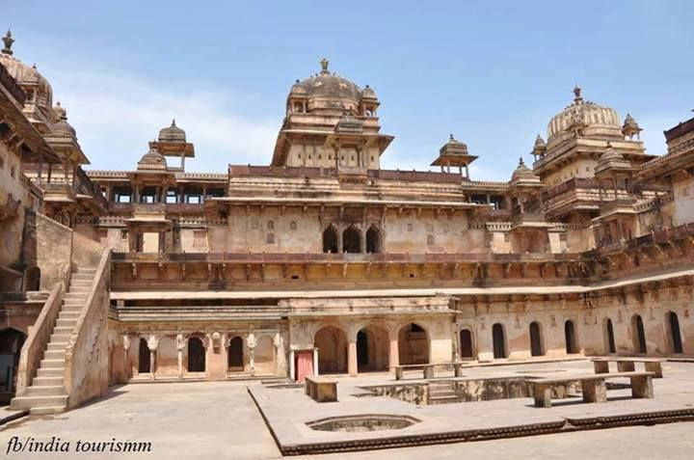
On time transfer to Agra Cantt station to board train for Jhansi. Meeting and assistance upon arrival and drive to Orchha. Upon arrival check in at hotel in Orchha.
Afternoon proceed for sightseeing tour of Orchha – A Living Legacy of Bundela Grandeur: Explore the remarkable heritage of Orchha, a medieval town steeped in Bundela history and distinguished by its magnificent palaces, temples and artistic traditions. Begin with the Jahangir Mahal, an imposing architectural masterpiece commissioned in honour of Emperor Jahangir. Its elegant design represents a remarkable synthesis of Hindu and Islamic architectural traditions, expressed through its graceful domes, ornate balconies, intricate stonework and beautifully proportioned courtyards. Continue to the Raj Mahal, the former royal residence renowned for its exceptional collection of mural paintings. The beautifully preserved murals, particularly those depicting religious themes and episodes from Hindu mythology, provide a fascinating glimpse into the artistic refinement and devotional traditions of the Bundela court. Visit the unique Ram Raja Temple, housed within a former royal palace and revered as the only temple in India where Lord Rama is worshipped as a reigning king. The distinctive transformation of a palace into a living temple lends the site an extraordinary cultural and spiritual character, with daily rituals continuing as an integral part of Orchha’s living heritage. The architectural splendour continues at the Chaturbhuj Temple, an imposing structure dedicated to Lord Vishnu and traditionally associated with his four-armed form. Its distinctive cross-shaped plan, soaring towers and monumental proportions make it one of Orchha’s most impressive landmarks. Finally, visit the Lakshminarayan Temple, celebrated for its harmonious blend of temple and fort-like architectural elements and its remarkably preserved interior murals. The paintings combine religious imagery with scenes reflecting the social and cultural life of the period, adding another fascinating dimension to Orchha’s artistic legacy.

Dinner and overnight stay at hotel in Orchha

30 MAR’27 | DAY 16: | ORCHHA – KHAJURAHO (172Kms, 03Hrs drive)
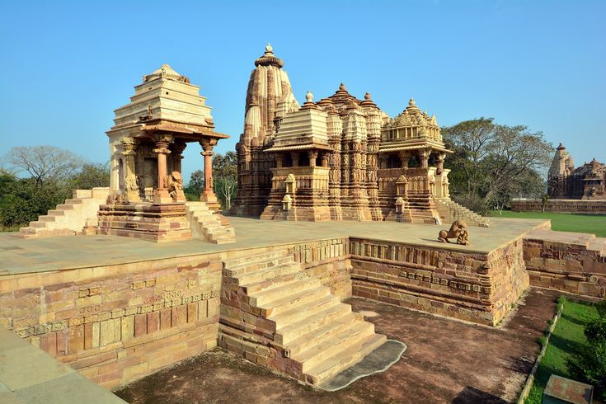
Morning after breakfast drive to Khajuraho. Upon arrival check in at hotel in Khajuraho.
Afternoon proceed for sightseeing tour of Khajuraho – A Celebration of Sacred Art and Architectural Brilliance: Spend a fascinating half-day exploring the Western and Eastern Groups of Temples at Khajuraho, a remarkable UNESCO World Heritage Site celebrated for its extraordinary architecture, intricate stone carvings and remarkable artistic expression. Built during the Chandela period, these temples represent one of the finest achievements of medieval Indian temple architecture. Begin with the Western Group of Temples, the most celebrated and architecturally impressive collection at Khajuraho. Its undisputed highlight is the magnificent Kandariya Mahadev Temple, rising approximately 32 metres and adorned with an extraordinary profusion of finely sculpted figures. Its walls and façades showcase deities, celestial beings, musicians, dancers, mythical creatures and sensuous human forms, demonstrating the exceptional artistry and sophisticated craftsmanship of the Chandela sculptors. Among the other notable monuments is the Chaunsath Yogini Temple, one of the earliest temples in Khajuraho and distinctive for its granite construction. Visit the Devi Jagadamba Temple, dedicated to the Mother Goddess and renowned for its graceful architectural proportions and beautifully executed sculptures. The Chitragupta Temple, dedicated to Surya, the Sun God, is another highlight, distinguished by its elegant carvings and finely detailed sculptural panels. Continue to the Eastern Group of Temples, where Hindu and Jain traditions coexist harmoniously, reflecting Khajuraho’s remarkable spirit of religious tolerance and artistic diversity. Among the Jain monuments, the Parsvanath Temple is the largest and most finely decorated, celebrated for its exquisite carvings and remarkably detailed sculptural ornamentation. Also visit the Adinatha Temple, dedicated to the first Jain Tirthankara, and the elegant Ghantai Temple, named for its distinctive bell-and-chain motifs carved into the pillars. The Vamana Temple, dedicated to an incarnation of Lord Vishnu, further enriches the architectural ensemble with its beautifully proportioned structure and intricate exterior sculptures.

Dinner and overnight stay at hotel in Khajuraho

31 MAR’27 | DAY 17: | KHAJURAHO – VARANASI (VANDE BHARAT EXPRESS – 15:20Hrs / 23:10Hrs)
Morning after breakfast on time transfer to Khajuraho station to board train for Varanasi. Meeting and assistance upon arrival at Varanasi station and transfer to hotel. Upon arrival check in at hotel in Varanasi.

Overnight stay at hotel in Varanasi

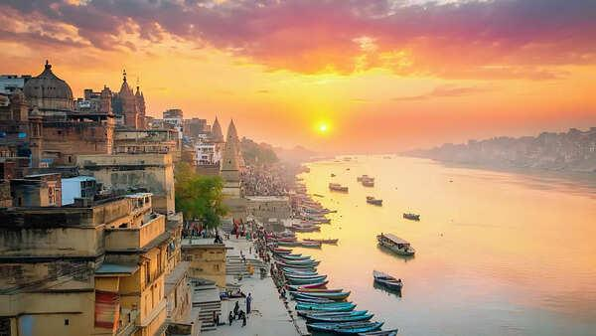
01 APR’27 | DAY 18: | VARANASI
Sunrise Boat Ride on the Ganges & Visit to Vishwanath Temple: Begin the day with an early morning boat ride on the sacred River Ganges, one of the most evocative experiences in Varanasi. As the first rays of sunlight gently illuminate the riverfront, the ancient ghats gradually awaken, revealing a timeless panorama of spirituality, devotion, and daily life. From the tranquil waters, witness pilgrims gathering along the ghats to bathe in the holy river, offer prayers, and perform traditional rituals. The sight of devotees carrying out centuries-old practices against the backdrop of Varanasi’s historic riverfront offers a deeply atmospheric glimpse into the spiritual traditions that continue to shape the city. As the sun rises above the horizon, the changing light casts a golden glow across the river and the centuries-old architecture lining its banks. Seen from a boat, this peaceful moment creates a quietly uplifting and contemplative experience, allowing visitors to appreciate Varanasi from an entirely different perspective. The boat journey also offers views of the city’s cremation ghats, where ancient Hindu funeral traditions continue to be observed. These sacred spaces provide a profound insight into the Hindu understanding of life, death, and the eternal cycle of existence. Visitors are encouraged to observe respectfully and discreetly. Later, visit the revered Shri Kashi Vishwanath Temple, one of the most sacred temples dedicated to Lord Shiva. Often referred to as the Golden Temple because of its distinctive gold-plated towers, the temple holds immense spiritual significance for Hindu devotees.

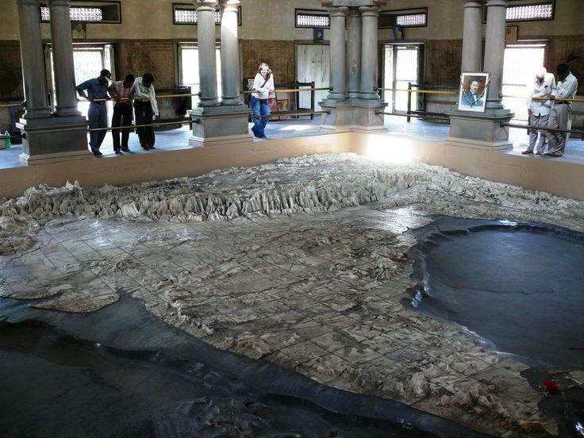
Return back to hotel for freshen up, have your breakfast and get ready for Varanasi Heritage & Temple Tour: Discover another fascinating facet of Varanasi on a half-day exploration through its spiritual heritage, religious traditions, architecture, and intellectual legacy. Beyond the sacred ghats of the Ganges, this experience introduces visitors to a remarkable collection of temples and cultural landmarks that reflect the city’s enduring importance as a centre of faith and learning. Begin with a visit to the Bharat Mata Temple, a unique temple dedicated not to a traditional deity but to the spirit of India itself. Its principal attraction is an impressive three-dimensional marble relief map of India, offering a distinctive representation of the country’s geographical landscape and making the temple a fascinating cultural experience. Continue to the Durga Temple, an elegant shrine dedicated to Goddess Durga and distinguished by its striking red-coloured architecture. The visit is followed by the Tulsi Manas Temple, a modern marble temple associated with the revered poet-saint Goswami Tulsidas. Its walls are beautifully inscribed with verses and scenes from the Ramcharitmanas, the celebrated Hindi rendition of the Ramayana, bringing the epic’s timeless teachings to life through art and literature. The tour continues to the New Vishwanath Temple, situated within the grounds of Banaras Hindu University and known for its impressive height and distinctive architecture. The temple is dedicated to Lord Shiva and is an important spiritual landmark of the university campus. Non-Hindus are not permitted inside the temple. Drive through the expansive campus of Banaras Hindu University (BHU), one of India’s most renowned centres of education and learning, and visit its museum, which offers further insight into the artistic and cultural heritage of the region. Conclude the tour with a view of the Alamgir Mosque, traditionally associated with the Mughal Emperor Aurangzeb. Perched above the Ganges, the mosque presents an intriguing architectural contrast and adds another historical layer to Varanasi’s extraordinarily diverse cultural landscape.
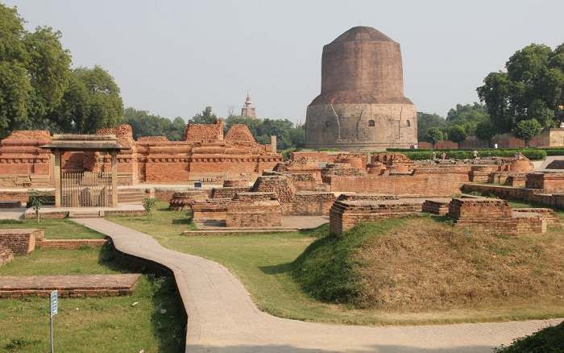
Afternoon explore Sarnath, one of the most revered Buddhist pilgrimage sites in India and a place of profound historical and spiritual significance. Located just outside Varanasi, Sarnath is traditionally regarded as the site where Gautama Buddha delivered his first sermon after attaining enlightenment, setting in motion the teachings that would become the foundation of Buddhism. The visit begins with the archaeological ruins, dominated by the magnificent Dhamek Stupa, an imposing structure believed to mark the spot where Buddha delivered his first sermon to his five disciples. Rising prominently from the surrounding ruins, the stupa stands as a powerful symbol of Buddhism and attracts pilgrims and visitors from across the world. Continue through the remains of the ancient monasteries and temples, which offer a fascinating glimpse into Sarnath’s past as an important centre of Buddhist learning and spiritual practice. Among the archaeological treasures is the remains of the Ashoka Pillar, erected during the reign of Emperor Ashoka and originally rising more than 20 metres. Its celebrated Lion Capital, now preserved in the Sarnath Museum, has become one of the most recognisable symbols of India and forms the inspiration for the country’s national emblem. A visit to the Sarnath Museum provides an opportunity to admire the remarkable collection of sculptures, archaeological discoveries, and artefacts unearthed from the surrounding site. Among its most prized exhibits is the exquisitely carved Lion Capital of Ashoka, renowned for its artistic refinement and historical significance.

END OF THE SERVICES

TOUR COST:
CATEGORY | COST PER PERSON
Towards the cost for North India tour | Euro 1799 per person
Single Room Supplement | USD 687 per Single

CiTY | HOTEL 4 STAR | LINKS | NIGHTS
Delhi | Park Inn By Radisson IP Extension or similar | Park Inn By Radisson IP Extension | 02 Night
Jaisalmer | Dessert Tulip or similar | Dessert Tulip | 02 Night
Jodhpur | Ranbanka Palace or similar | Ranbanka Palace | 01 Night
Udaipur | Rajputana Palace Resort | Rajputana Palace Resort | 02 Night
Bundi | Hadoti Palace or similar | Hadoti Palace | 01 Night
Jaipur | Shahpura House or similar | Shahpura House | 02 Night
Ranthambore | Nahargarh or similar | Nahargarh Ranthambore | 02 Night
Agra | Grand Mercure or similar | Grand Mercure | 02 Night
Orchha | Orchha Palace or similar | Orchha Palace | 01 Night
Khajuraho | Ramada By Wyndham or similar | Ramada By Wyndham | 01 Night
Varanasi | Hotel Tridev or similar | Hotel Tridev | 02 Night
Total, number of nights |  |  | 18 Nights

Air:
Date | Sector | Flight | Departure | Arrival | Fare
17 Mar’27 | Delhi – Jaisalmer | 6E 6677 | 13:10Hrs | 15:15Hrs | Euro 99 per person
02 Apr’27 | Varanasi – Delhi | 6E 2266 | 16:35Hrs | 18:10Hrs | Euro 85 per person

*******Air Fare are subject to change without notice*******

Our prices include:

Accomodation based on Double room.

Half Board basis as per program (Breakfast, Dinner) and full board in Ranthambore (Breakfast, Lunch, Dinner)

All arrival/departure transfer, sightseeing tour excursions by Air-conditioned Tempo Traveller/Urbania.

Entrance fees to Monuments

Italian speaking guide as per program

Morning and afternoon safari by canter at Ranthambore

Aarti ceremony in Varanasi

Early Morning boat ride in Varanasi

Elephant ride at Amer Fort in Jaipur

Boat ride at Lake Pichola in Udaipur

Camel ride in Jaisalmer

Train tickets for travel sector Agra to Jhansi by Vande Bharat Express in Air-Conditioned Chair car

Train tickets for travel sector Varanasi to Khajuraho by Vande Bharat Express in Air-Conditioned Chair Car

02 night in Delhi with breakfast and Dinner basis.

02 night in Varanasi with breakfast and Dinner basis.

01 night in Khajuraho with breakfast and Dinner basis.

01 night in Orchha with breakfast and Dinner basis.

02 night in Agra with breakfast and Dinner basis.

02 night in Ranthambore with full board basis (Breakfast, Lunch, Dinner).

02 night in Jaipur with breakfast and Dinner basis.

02 night in Udaipur with breakfast and Dinner basis.

01 night in Jodhpur with breakfast and Dinner basis.

02 night in Jaisalmer with breakfast and Dinner basis.

01 night in Bundi with breakfast and Dinner basis.

Government tax.

Our prices do not include:

Air fare

Entry visa.

Visas can be obtained online at: www.indianvisaonline.gov.in

Tips for guides (at the client's discretion).

Travel and cancellation insurance (optional).

Beverages.

Any services not mentioned as included, including personal extras such as telephone calls, laundry

service, etc.

